Task 1: Create student table in database and insert the data

CREATE TABLE STUDENTS(

StudentName varchar2(50),

StudentRollNo varchar2(15) ,

S_Class varchar2(50),

Age number(2),

FathersName varchar2(50),

CONSTRAINT s_pk PRIMARY KEY (StudentRollNo)

);

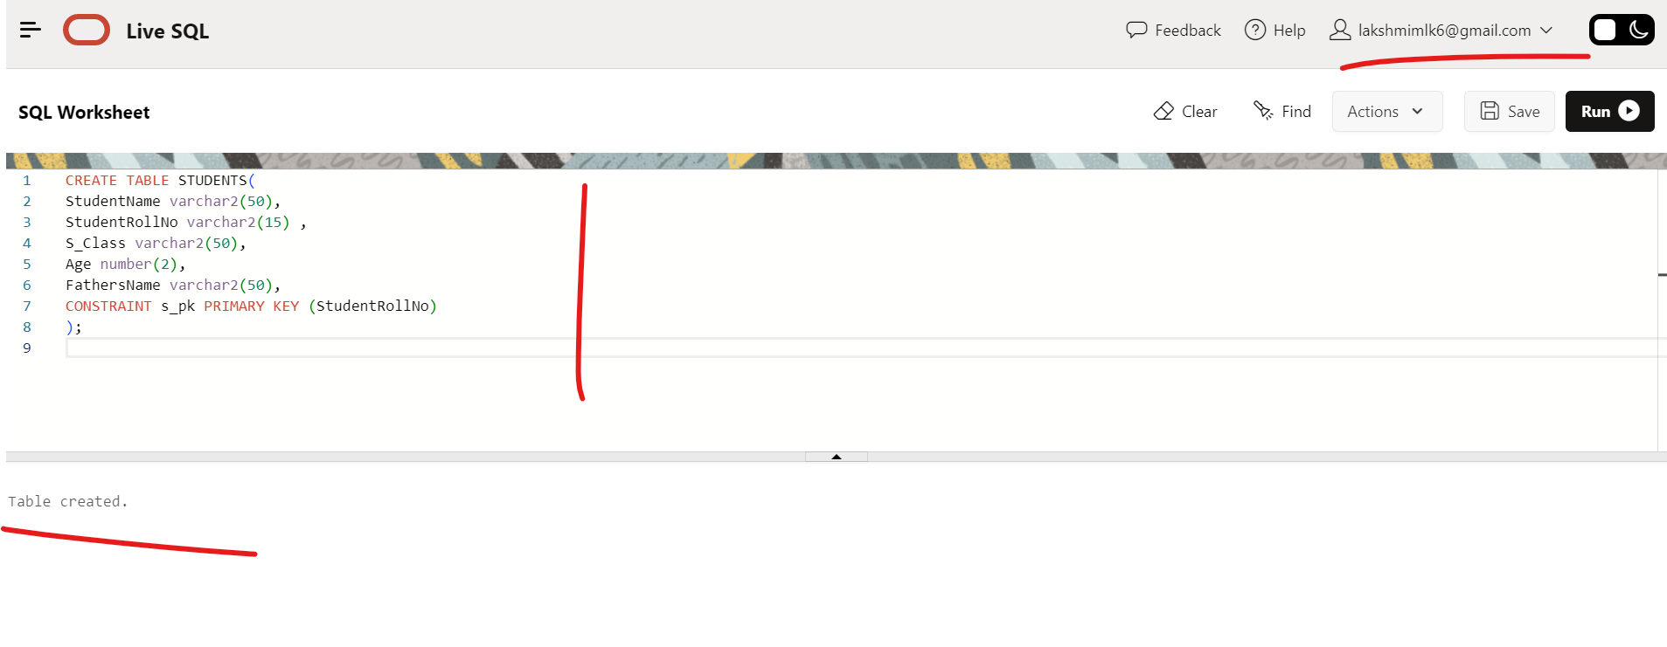

INSERT INTO STUDENTS VALUES (‘JYOSNA’,’MLKSP01’,'X',19, ‘CHANDRA’);

INSERT INTO STUDENTS VALUES (‘Srusti MISHRA','MLKSP02','XI',18,'SURESH MISHRA');

INSERT INTO STUDENTS VALUES ('VAMSI', 'MLKSP03','IX',17,’PITTA’);

INSERT INTO STUDENTS VALUES ('MONISHA', 'MLKSP05','XII',18,’VENKAT');

INSERT INTO STUDENTS VALUES ('SUMITA SHARMA', 'MLKSP06','IV',14,'AJAY SHARMA');

INSERT INTO STUDENTS VALUES ('NANDINI GUPTA', 'MLKSP07','VII',18,'RAM GUPTA');

INSERT INTO STUDENTS VALUES ('RAM KUMAR', 'MLKSP08','X',17,'RAMAN KUMAR');

INSERT INTO STUDENTS VALUES ('LAKSHMI M', 'MLKSP09','VII',18,'SUBRAMANYAM');

INSERT INTO STUDENTS VALUES (‘LAKSHMI M’, 'MLKSP4','X',19, 'SUBRAMANYAM');

Task 2 : Write sql query to find out total number of students in each class

SELECT S_CLASS, COUNT(StudentRollNo) AS TOTAL_STUDENTS from STUDENTS

GROUP BY S_CLASS ORDER BY TOTAL_STUDENTS

Task 3- Write sql query to find out average age of students in each class.

SELECT S_CLASS, AVG(Age) AS AVERAGE_AGE_PER_CLASS from STUDENTS

GROUP BY S_CLASS;

Task 4- Write sql query to find out the number of students having same roll no.

SELECT COUNT(StudentRollNo) from STUDENTS

GROUP BY StudentRollNo HAVING COUNT(StudentRollNo) > 1 ;

Task 5 : Write sql query to view the duplicate name of a student from the table

SELECT StudentName from STUDENTS

GROUP BY StudentName HAVING COUNT(StudentName) > 1 ;

